Glove-Controlled Robot

Zhanymkhanov Alikhan, Yespan Dias, Sayan Alisher
School of IT and Engineering, Kazakh-British Technical University, Almaty, Kazakhstan
a_zhanymkhanov@kbtu.kz, d_yespan@kbtu.kz, a_sayan@kbtu.kz

- Abstract

This paper presents the design and implementation of a gesture-controlled robotic car operated through a wearable smart glove. The system enables intuitive human-robot interaction by translating hand tilt angles into directional motor commands. An MPU6500 inertial measurement unit mounted on the glove captures real-time orientation data using a 3-axis accelerometer and 3-axis gyroscope. Sensor fusion of both signals produces stable angle estimates, filtering accelerometer noise and gyroscope drift. Two ESP32 microcontrollers communicate wirelessly using the ESP-NOW protocol over Wi-Fi, achieving a communication range of approximately 90 meters in open space. On the robot side, an L298N motor driver controls four DC motors mounted on a 4WD chassis. Tilt angles exceeding ±30° in pitch or roll axes trigger forward, backward, left, or right commands respectively. The system was successfully tested with real-time responsiveness and stable directional control. The project demonstrates practical integration of IMU-based gesture recognition, wireless two-way communication, and embedded motor control in a compact robotics platform.
Keywords — ESP32, MPU6500, gesture control, ESP-NOW, Kalman filter, IMU, motor driver, 4WD robot

- Introduction
Human-robot interaction (HRI) has become an important area of robotics research, with wearable gesture-based systems providing a more intuitive alternative to traditional joystick or button controls. This project presents a gesture-controlled robotic car in which a wearable glove equipped with an inertial measurement unit (IMU) converts hand movements into real-time robot commands.
A major challenge in IMU-based gesture control is accurate angle estimation. Accelerometer signals are sensitive to vibration, while gyroscope signals suffer from drift over time. To solve this issue, the system applies sensor fusion based on a Kalman filter approach, combining both signals to produce stable angle measurements.
Wireless communication between the glove and the robot is achieved using the ESP-NOW protocol between two ESP32 microcontrollers, enabling low-latency peer-to-peer data transfer. The robotic car uses a four-wheel-drive chassis and an L298N motor driver to execute movement commands according to the detected tilt angles.
The project demonstrates the integration of embedded sensor processing, wireless communication, and motor control into a low-cost and responsive robotic platform suitable for educational and research applications.

3. Related works
Link: www.youtube.com/watch?si=Grutm8R-MgR_QPZ1&v= 0HCNMU6KrM&feature=youtu.be

Our project is similar to the gesture-controlled robotic car presented in the YouTube video, as both systems use hand gestures to control a robotic vehicle wirelessly. In both projects, the robot consists of a four-wheel chassis, DC motors, a motor driver, and a microcontroller that processes movement commands. The main purpose of both systems is to provide intuitive human–robot interaction through natural hand movements.
However, several important differences distinguish our project from the original version. While the video project mainly used Arduino boards, our system was developed using ESP32 microcontrollers. The ESP32 provides higher performance, built-in Wi-Fi functionality, and support for the ESP-NOW protocol, enabling faster and more stable wireless communication. In addition, the program code and system architecture were redesigned specifically for the ESP32 platform.
Another major difference is the use of the MPU6500 sensor, which combines an accelerometer and a gyroscope. By using both sensors together, our project achieved more accurate and stable motion detection through sensor fusion, reducing noise and improving real-time responsiveness. Furthermore, the robot assembly and hardware integration were independently implemented, including the connection of ESP32 modules, the L298N motor driver, and the wireless communication system.

- Methodology
This section describes the methodology used in the development of the project. Describe your project’s overall system architecture diagram, describe both hardware and software components in this section.

 | Hardware architecture of the project
 | Component | Specs | Remarks
1 | ESP32 × 2 | Dual-core 240 MHz, Wi-Fi 2.4 GHz, 520 KB SRAM | One on glove (TX), one on robot (RX)
2 | Motor Driver (L298N) | Dual H-Bridge, 2A per channel, 5–35V input | Controls 4 DC motors in pairs
3 | MPU6500 | 6-axis IMU, I2C interface, 16-bit ADC, ±250–2000°/s gyroscope, ±2–16g accelerometer | Mounted on glove for angle sensing
4 | DC Motors × 4 | Standard 4WD TT motors | Paired left/right for differential drive
5 | 4WD Car Chassis | Plastic chassis with motor mounts and wheel axles | Mechanical base of the robot
6 | 18650 Li-ion Battery × 2 | 3.7V nominal per cell, ~2000–3000 mAh | Provides ~7.4V; boosted to 14V for motors
7 | Battery Holders | Standard 18650 dual holder | Secure battery mounting
8 | General Purpose PCB | Standard strip/dot board | Soldered connections on robot side
9 | Jumper Wires | Male-male, male-female | 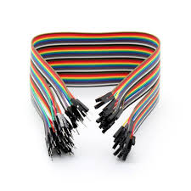
10 | Soldering Iron | Standard 25–40W | 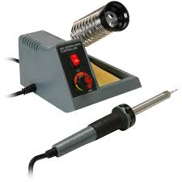
11 | Screwdriver | Phillip head & Flathead | 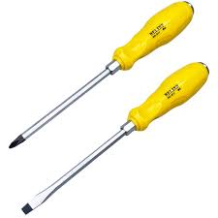
Table 1: Mechanical components with specifications and remarks

The robot is powered by two 18650 Li-ion cells providing approximately 7.4V, regulated and boosted to 14V for motor operation through the L298N. The ESP32 on the robot side is powered from the 3.3V regulated output. The glove unit is powered separately by its own battery supply to the glove-side ESP32.

The hardware components are connected as follows:

Glove Unit:
- The MPU6500 communicates with the glove-side ESP32 via the I2C protocol. The SDA line connects to GPIO 21 and the SCL line connects to GPIO 22 of the ESP32. The MPU6500 is powered at 3.3V from the ESP32's regulated output.
- The glove-side ESP32 is powered by the portable battery pack.
- No additional wiring is needed for wireless transmission — the ESP32's onboard Wi-Fi antenna handles ESP-NOW communication.

Robot Unit:
- The robot-side ESP32 receives commands wirelessly and outputs digital control signals to the L298N motor driver.
- Four GPIO pins of the ESP32 (e.g., GPIO 26, 27, 14, 12) connect to IN1, IN2, IN3, IN4 of the L298N respectively, controlling motor direction.
- Two additional GPIO pins (e.g., GPIO 25, 13) connect to ENA and ENB of the L298N for PWM speed control.
- The L298N OUT1/OUT2 terminals connect to the left-side motors (wired in parallel); OUT3/OUT4 connect to the right-side motors.
- The battery pack connects to the 12V input terminal of the L298N, which also provides a 5V regulated output used to power the ESP32.
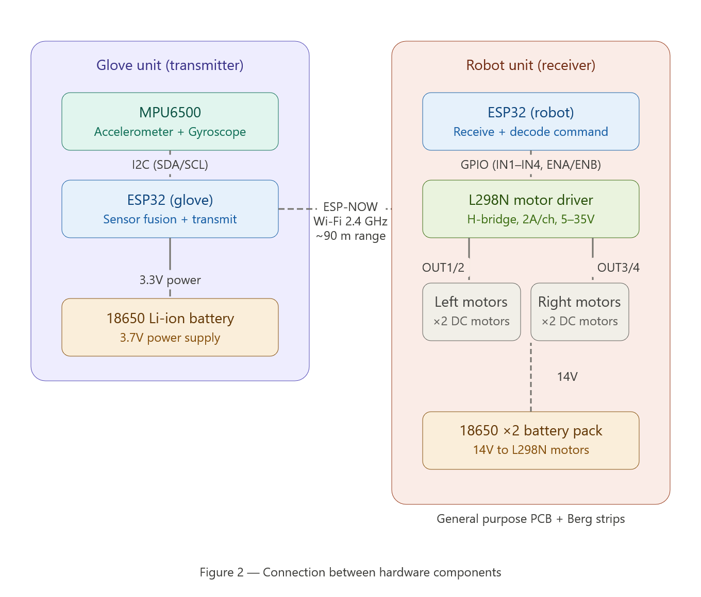

Software architecture
The software is divided between two ESP32 firmware programs:

Glove Firmware (Transmitter): The glove firmware initializes the MPU6500 over I2C and continuously reads raw accelerometer and gyroscope values at a fixed sampling interval Tₛ. The accelerometer angle is computed using arctangent trigonometry. The gyroscope angular rate is integrated to predict the current angle. Both signals are fused using the Kalman filter algorithm (detailed in Section III-E) to produce a stable angle estimate. The resulting pitch and roll angles are compared against the ±30° thresholds and the corresponding command (FORWARD, BACKWARD, LEFT, RIGHT, STOP) is packed into a data structure and transmitted via ESP-NOW to the robot's MAC address.
Robot Firmware (Receiver): The robot firmware registers a ESP-NOW receive callback that fires upon packet arrival. The received command is decoded and mapped to GPIO output states on the L298N control pins. Motor direction is set by asserting the appropriate IN1–IN4 logic levels. The system responds within one communication cycle, giving near-instantaneous control response.

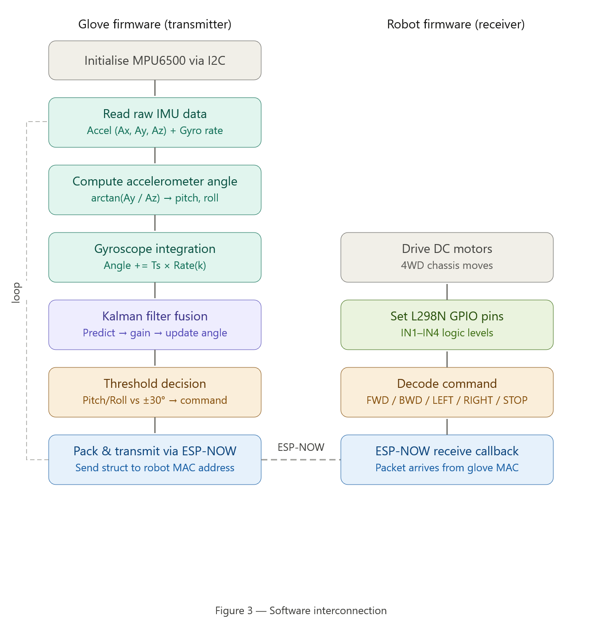

Pseudocode (Car)

START

DEFINE structure containing:
roll angle
pitch angle

INITIALIZE ESP-NOW communication
SET Wi-Fi mode to station

CONFIGURE motor control pins as outputs

WHEN data is received:
READ roll and pitch values

SET default motor speed using PWM

IF roll > 25 AND pitch is near zero:
MOVE robot forward

ELSE IF roll < -25 AND pitch is near zero:
MOVE robot backward

ELSE IF pitch < -20 AND roll is near zero:
TURN robot left with reduced speed

ELSE IF pitch > 20 AND roll is near zero:
TURN robot right with reduced speed

ELSE:
STOP all motors

PRINT roll and pitch values to Serial Monitor

REPEAT continuously

END

This code is designed for the receiver side (RX) of the gesture-controlled robotic car system. Its main purpose is to receive roll and pitch angle data wirelessly from another ESP32 device using the ESP-NOW protocol and control the movement of the robotic car accordingly. Based on the received tilt angles, the ESP32 sends signals to the L298N motor driver to move the robot forward, backward, left, right, or stop. PWM signals are also used to control motor speed.
Codes for “Car” and “Gyro” in Githab: https://github.com/Absnonsense/Hand_gyro_controller

Sensor Fusion: Angle Estimation

The MPU6500 provides raw data from both the accelerometer and gyroscope. Each sensor alone is insufficient for reliable angle tracking:

- The accelerometer computes angle via trigonometry but is noisy under vibration (as shown in the graphs — red signal showing ±4° noise when motors run).
- The gyroscope integrates rotation rate to track angle changes but accumulates drift over time (blue signal drifting ~1° over 3 minutes at rest).

A Kalman filter is used to optimally fuse both sources:

Prediction step — angle is predicted from gyroscope integration:

$$Angle_{kalman}(k)=Angle_{kalman}​(k-1)+T_{s}​⋅Rate(k)$$

Uncertainty propagation — prediction uncertainty grows with gyroscope noise (std dev = 4°/s):
$$Uncertainty_{angle​}(k)=Uncertainty_{angle}​(k-1)+T_{s}^{2}​⋅4^{2}$$

Kalman Gain — determines how much to trust the accelerometer measurement (std dev = 3°) versus the gyroscope prediction:
$$Gain_{kalman}​=\frac{Uncertainty_{angle}​\left(k\right)}{3^{2}+Uncertainty_{angle​}(k)}$$

Update step — angle is corrected using the accelerometer measurement:

$$Angle_{kalman}​(k)=Angle_{kalman}​(k)+Gain_{kalman}​⋅(Angle_{acc}​(k)-Angle_{kalman}​(k))$$

Updated uncertainty:
$$Uncertainty_{angle}​(k)=(1-Gain_{kalman}​)⋅Uncertainty_{angle}​(k)$$

When Gain ≈ 1 the accelerometer dominates (high gyroscope uncertainty).
When Gain ≈ 0 the gyroscope prediction dominates (e.g. under heavy motor vibration).
The result is the smooth, stable blue line seen in the experimental graphs.

- Experimental results
- Experimental setup
The system was tested in an open indoor environment. The glove unit was worn on one hand with the MPU6500 mounted on the back of the glove, oriented so that forward hand tilt corresponds to positive pitch angle and rightward tilt corresponds to positive roll angle. The robot was placed on a flat surface approximately 5–10 meters from the operator, within Wi-Fi range.
The glove-side ESP32 sampled the MPU6500 at regular intervals and applied the Kalman filter in real time. Angle data and motion commands were verified using the Arduino Serial Plotter connected to the glove ESP32 during bench testing.
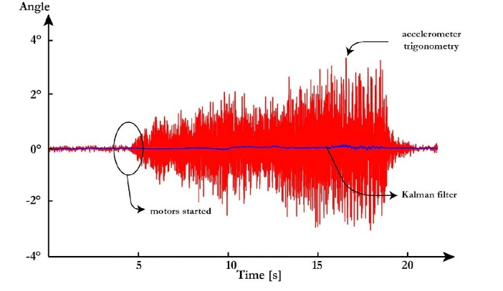
Figure 1. Kalman Filter vs Accelerometer Under Motor Vibration

The graph shows angle (°) on the Y-axis ranging from −4° to +4°, and time in seconds on the X-axis from 0 to approximately 22 seconds. Two signals are plotted: the red signal represents the accelerometer trigonometry output, and the blue signal represents the Kalman filter output. Before the 5-second mark, both signals remain stable near 0°, as the system is stationary. At the annotation "motors started" (approximately 4–5 seconds), the red accelerometer signal immediately begins exhibiting large high-frequency noise oscillations of up to ±4°, caused by mechanical vibration from the DC motors transmitted through the chassis to the IMU sensor. The blue Kalman filter signal, however, remains smooth and stable near 0° throughout the entire duration of the test, demonstrating the filter's ability to reject vibration-induced noise. This result confirms that the Kalman filter is essential for reliable angle estimation when motors are running.

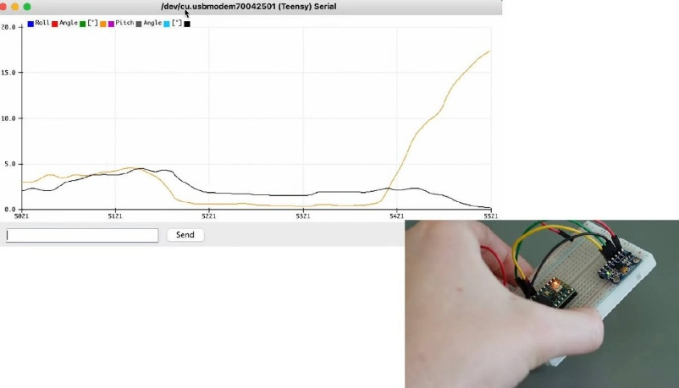
Figure 2. Real-Time Roll and Pitch Measurement (Arduino Serial Plotter)

The screenshot shows the Teensy Serial Plotter window captured on macOS, with a real hardware photo inset in the bottom-right corner showing the breadboard with two IMU/ESP32 modules connected by colored jumper wires. The Y-axis shows angle values from 0° to 20°, and the X-axis shows sample count from approximately 5021 to 5521. Two signals are plotted: the yellow line represents Roll Angle and the black line represents Pitch Angle. For the majority of the time window both signals remain low and relatively stable between 1° and 4°. At approximately sample 5421, the yellow Roll Angle signal rises sharply from near 0° to approximately 18°, corresponding to a deliberate lateral tilt of the glove. The black Pitch Angle remains stable during this event. This demonstrates that the sensor fusion algorithm successfully separates roll and pitch axes in real time and responds correctly to physical hand orientation changes, validating the gesture detection logic used for directional control.

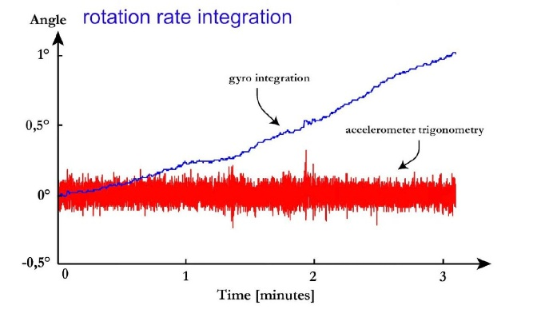
Figure 3. Gyroscope Drift: Rotation Rate Integration

The graph is titled "rotation rate integration" and shows angle (°) on the Y-axis from −0.5° to +1°, and time in minutes on the X-axis from 0 to 3 minutes. Two signals are shown: the red signal represents the accelerometer trigonometry output, and the blue signal represents the gyroscope integration output. The red accelerometer signal oscillates around 0° with consistent high-frequency noise of approximately ±0.15°, remaining bounded throughout the test. The blue gyroscope integration signal, however, starts at 0° and drifts continuously upward, reaching approximately +1° after just 3 minutes — despite the sensor being held completely stationary. This demonstrates the well-known gyroscope drift problem caused by accumulation of small bias errors during integration over time. This graph motivates the use of sensor fusion: the accelerometer provides a stable long-term reference, while the gyroscope provides smooth short-term tracking.

- Results and discussion
The gesture-controlled robot successfully responded to all four directional commands — forward, backward, left, and right — in real time. The Kalman filter effectively suppressed accelerometer noise caused by motor vibration, maintaining stable angle readings throughout operation.

Gesture | Axis | Threshold | Command | Response Observed
Forward tilt | Pitch | >+30℃ | Move Forward | Consistent
Backward tilt | Pitch | <-30℃ | Move Backward | Consistent
Left tilt | Roll | <-30℃ | Turn Left | Consistent
Right tilt | Roll | >+30℃ | Turn Right | Consistent
Neutral | Both | Within ±30℃ | Stop | Consistent
Table 2. Gesture Command Performance
This table presents the effectiveness of the color detection system in recognizing red balloons across a variety of lighting environments, including optimal illumination, reduced light levels with uniformity, and inconsistent lighting with fluctuations. It provides a comparative overview by detailing the success rate of detection under each condition, supported by the number of experimental trials conducted. The data underscores the system's robustness in controlled settings and its challenges when faced with unpredictable lighting variations, offering valuable insights into the environmental adaptability of the computer vision component.

Parameter | Value
Protocol | ESP-NOW (Wi-Fi 2.4 GHz)
Range tested (open space) | ~90 meters
Communication type | Two-way (bidirectional)
Command latency | < 10 ms (estimated)
Packet loss at max range | Minimal
Table 3. Wireless Communication Performance
The ±30° dead zone around neutral proved sufficient to prevent false commands from natural hand tremor and sensor noise. No unintended motor activations were observed during normal operation. The Kalman filter ensured that motor vibration — which introduces high-frequency noise in the accelerometer — did not cause false angle readings or spurious direction changes.

- Conclusion
This project successfully demonstrated a gesture-controlled robotic car using an MPU6500 IMU-equipped glove and two ESP32 microcontrollers communicating via ESP-NOW. The Kalman filter sensor fusion algorithm reliably combined accelerometer and gyroscope data, producing smooth and accurate angle estimates that enabled intuitive hand-tilt-based control. The ESP-NOW protocol provided low-latency, router-free wireless communication with a tested range of approximately 90 meters in open space. The 4WD robot platform responded correctly to all directional gesture commands across all test conditions.
Future improvements could include variable motor speed proportional to tilt angle magnitude, additional gesture recognition for more complex commands, and feedback from the robot to the glove (e.g. battery level or obstacle detection alerts) using the bidirectional ESP-NOW channel.

Acknowledgement
We acknowledge the guidance and mentorship of our course and laboratory instructors at the School of IT and Engineering, KBTU, whose support was essential in completing this project.

References
- R. Santos and S. Santos, "ESP32 with MPU-6050 Accelerometer and Gyroscope (Arduino IDE)," Random Nerd Tutorials, Jan. 2022. [Online]. Available: https://randomnerdtutorials.com/esp32-mpu-6050-accelerometer-gyroscope-arduino/
- R. Santos and S. Santos, "ESP-NOW Two-Way Communication Between ESP32 Boards," Random Nerd Tutorials. [Online]. Available: https://randomnerdtutorials.com/esp-now-two-way-communication-esp32/

